Amazon Elastic Container Service (ECS)

- Setup a highly available ecs cluster with load balancer and dynamic port mapping.
NOTE:
Your cluster should maintain atleast 6 tasks at any point of time and should be highly availble across multiple AZ's.
Use the below image from deployment:
sabair0509/hiring-app:works

Task Title
Setup a Highly Available ECS Cluster with Load Balancer & Dynamic Port Mapping
Objective
To deploy the Docker image:
sabair0509/hiring-app:works
Using:
- Highly Available ECS Cluster
- Minimum 6 running tasks at all times
- Multi-AZ Deployment
- Application Load Balancer (ALB)
- Dynamic Port Mapping
Prerequisites
Before starting, ensure:
- AWS Account configured
- Proper IAM permissions (ECS, EC2, ELB)
- Existing VPC with multiple subnets
- Security Groups configured
- Docker image available in registry
- Key Pair (optional for EC2 launch type)

Step-by-Step Implementation:

Step 1 – Create ECS Cluster
Action Performed
- Open Amazon Elastic Container Service (ECS)
- Navigate to Clusters
- Click Create Cluster
- Enter Cluster Name:
Hiring-app-Dev
- Select Infrastructure Type:
- Fargate and Self-managed instances
Evidence
- Cluster creation page displayed
- Cluster name configured

Step 2 – Configure Infrastructure Capacity
Action Performed
- Provisioning Model → On-Demand
- AMI → Amazon Linux
- Instance Type → t2.large
- Desired Capacity:
  - Minimum = 2
  - Maximum = 5
High Availability Consideration
- Multiple EC2 instances configured
- Capacity supports scaling
Evidence
- EC2 capacity settings configured

Step 3 – Configure Network Settings
Action Performed
- Selected VPC
- Selected Multiple Subnets
- Security Group → Default
High Availability Requirement
- Subnets distributed across multiple Availability Zones
Evidence
- Multi-AZ subnets selected

Step 4 – ECS Cluster Created
Action Performed
- ECS Cluster successfully created
Evidence
- Cluster Status → Active
- Registered Container Instances → 3

Service Creation

Step 5 – Create ECS Service
Action Performed
- Navigate to Cluster → Services
- Click Create Service
- Task Definition → Hiring-app
- Service Name → hiring-td-service
Evidence
- Service configuration screen displayed

Step 6 – Configure Scheduling Strategy
Action Performed
- Scheduling Strategy → Replica
- Desired Tasks:
6
Critical Requirement Achieved
- Minimum 6 tasks maintained
Evidence
- Desired task count configured

Step 7 – Configure Load Balancer
Action Performed
- Load Balancer Type → Application Load Balancer
- Container Port:
8080
- Host Port:
0 (Dynamic Port Mapping)
Dynamic Port Mapping Enabled
- ECS assigns random ports dynamically
- Prevents port conflicts
- Allows multiple tasks per instance
Evidence
- Port mapping configuration visible

Target Group Configuration
Step 8 – Create Target Group
Action Performed
- Target Type → Instances
- Protocol → HTTP
- Port → 8080
- Target Group Name:
hiring-app
Evidence
- Target group configuration completed
Step 9 – Configure Health Checks
Action Performed
- Health Check Protocol → HTTP
- Health Check Path → /
Purpose
- Monitor task health
- Ensure traffic routed only to healthy targets
Evidence
- Health check settings configured

Step 10 – Register Targets
Action Performed
- Selected ECS Instances
- Port → 8080
- Registered Targets
Evidence
- Targets Registered
- Target Health → Healthy

Load Balancer Creation
Step 11 – Create Application Load Balancer
Action Performed
- Load Balancer Name → hiring-app-loadbalancer
- Scheme → Internet Facing
- IP Address Type → IPv4
- Availability Zones → Multiple Subnets
High Availability Achieved
- Load balancer deployed across multiple AZs
Evidence
- Load balancer creation successful
Step 12 – Configure Listener
Action Performed
- Protocol → HTTP
- Port → 8080
- Default Action → Forward to Target Group:
hiring-app
Evidence
- Listener rules configured
Step 13 – Load Balancer Active
Evidence
- Load Balancer Status → Active
- DNS Name Generated

Final ECS Deployment Status
Step 14 – Tasks Running
Evidence
- Running Tasks → 6
- Service Status → Active
Requirement Met
- Minimum 6 tasks maintained
Step 15 – Infrastructure Validation
Evidence
- EC2 Instances → Running
- Status Checks → Passed
- Load Balancer → Active
Step 16 – Application Validation
Action Performed
- Accessed ALB DNS Name via Browser
Evidence
- Application Loaded Successfully
Displayed Output:
Welcome to Techie Horizon
Validation Steps
- ECS Service → Running Tasks = 6
- Target Group → Healthy Targets
- Load Balancer → Active
- Application Accessible via DNS
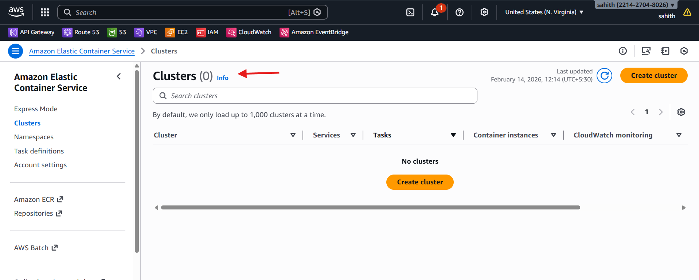
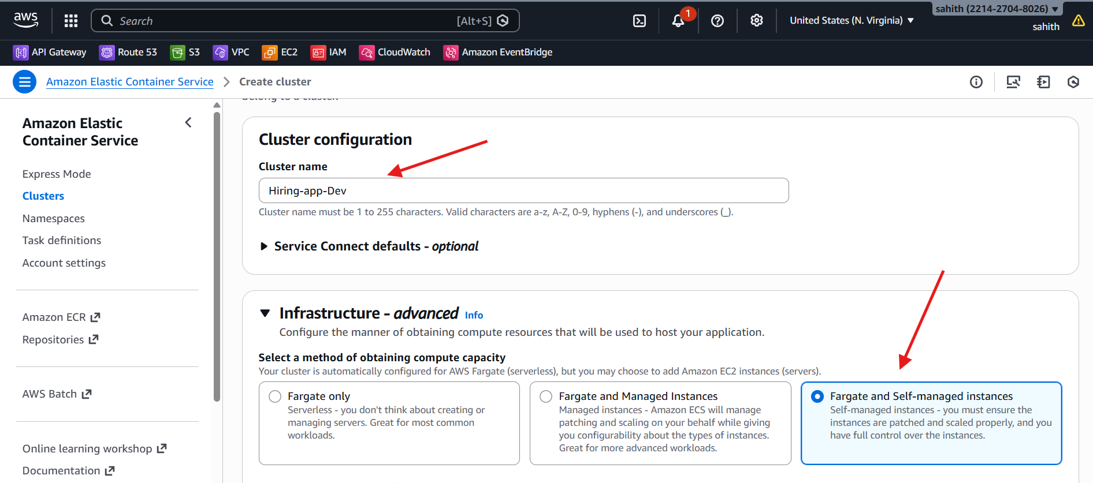
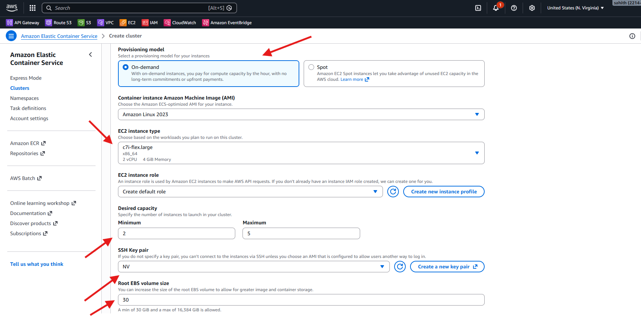
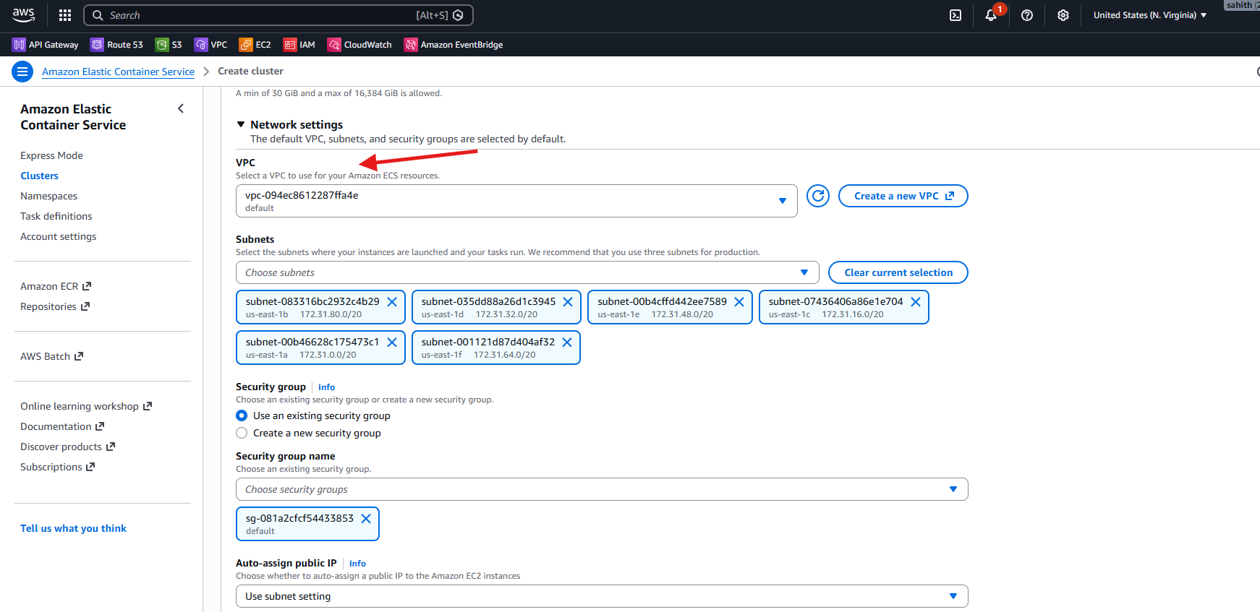
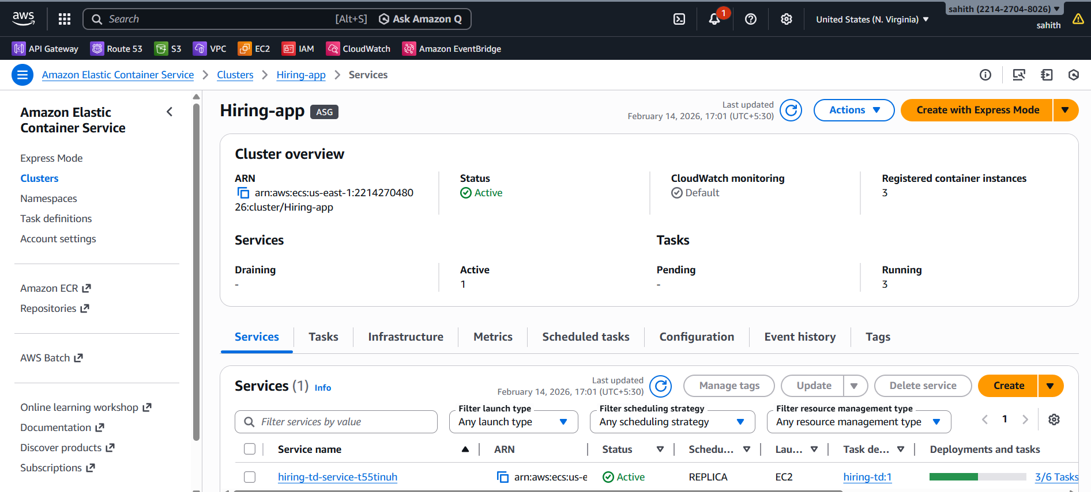
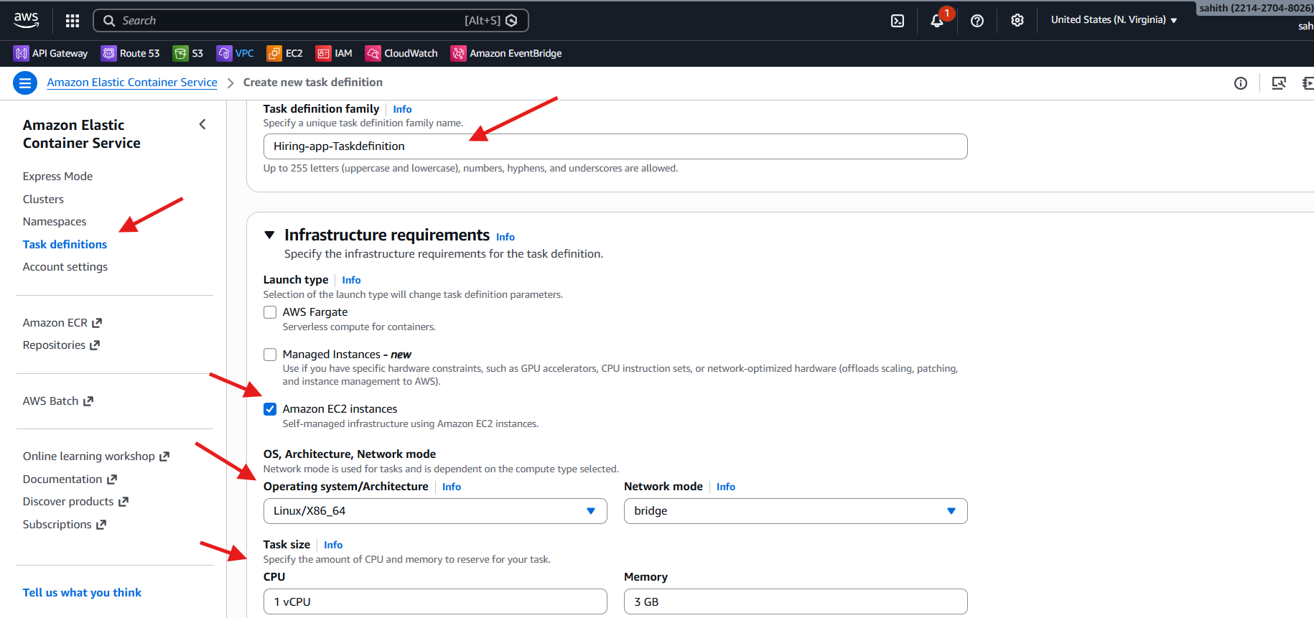
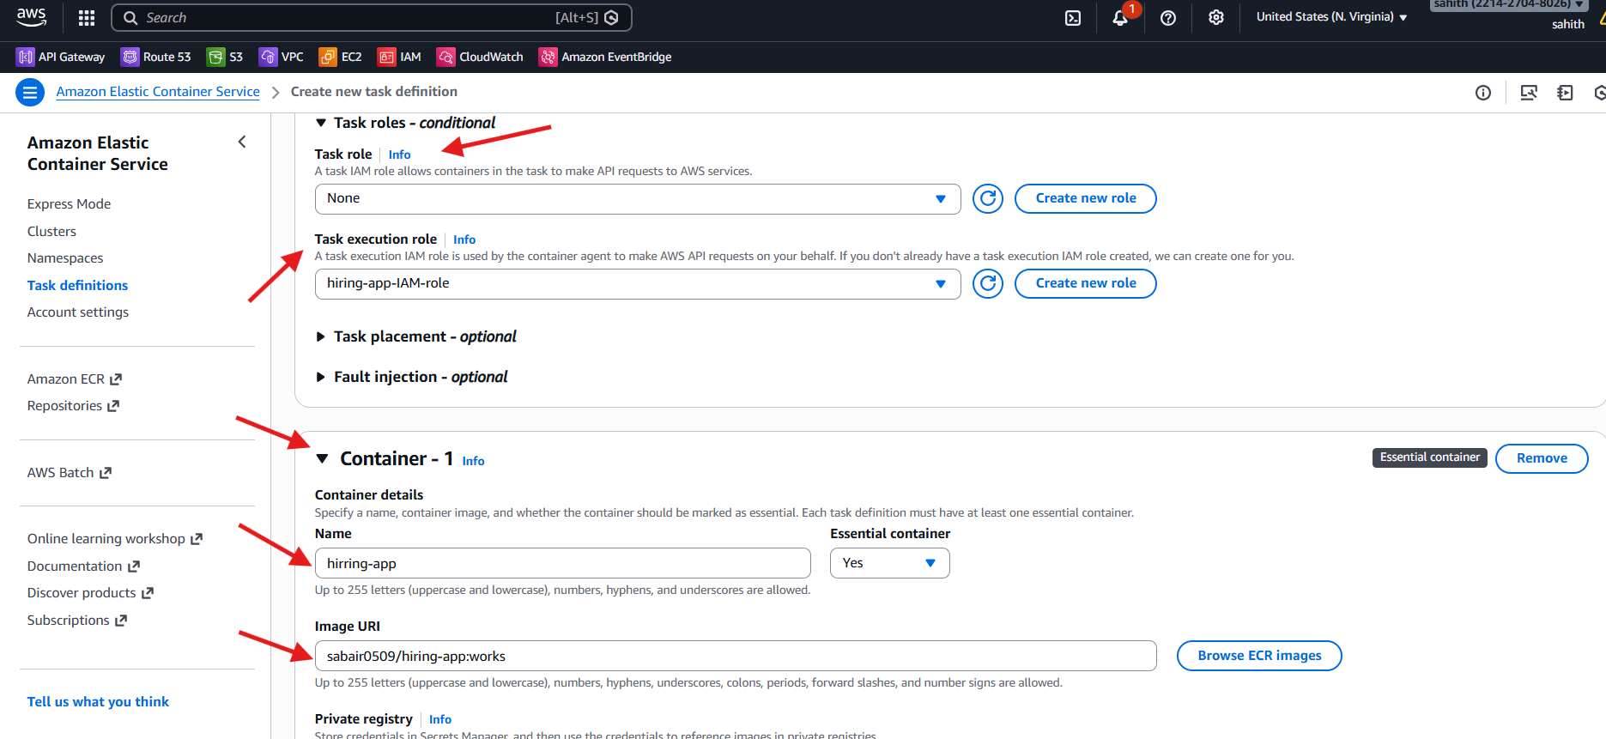
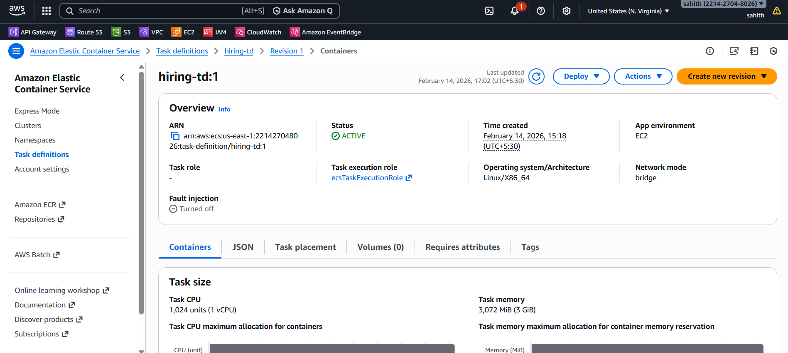
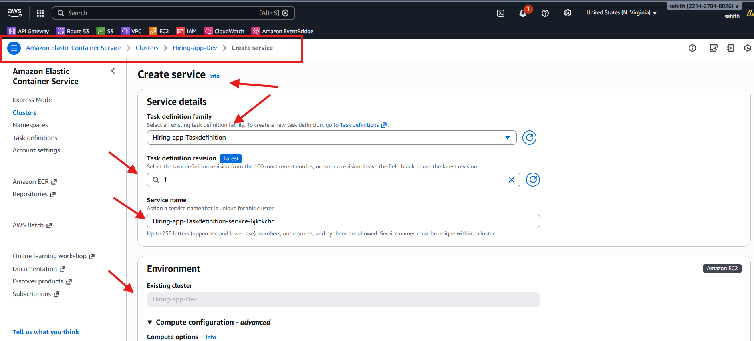
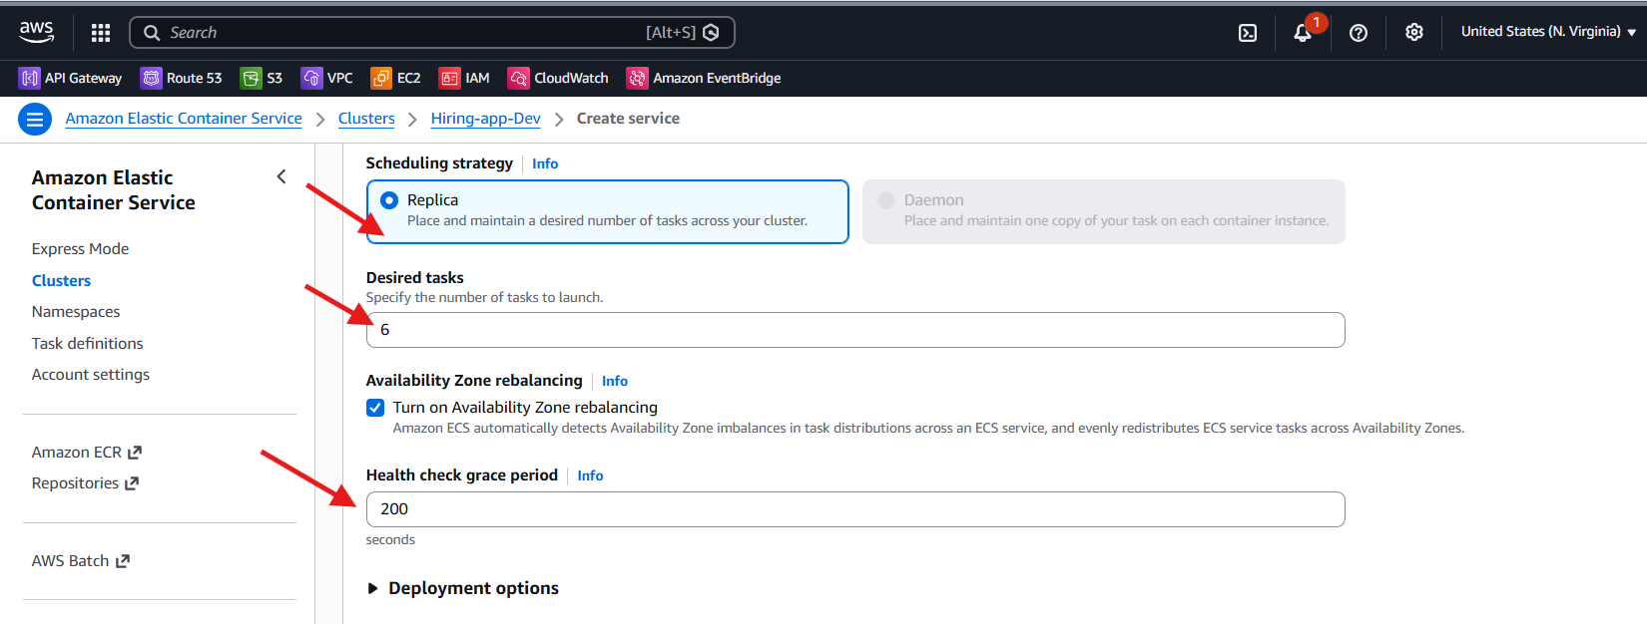
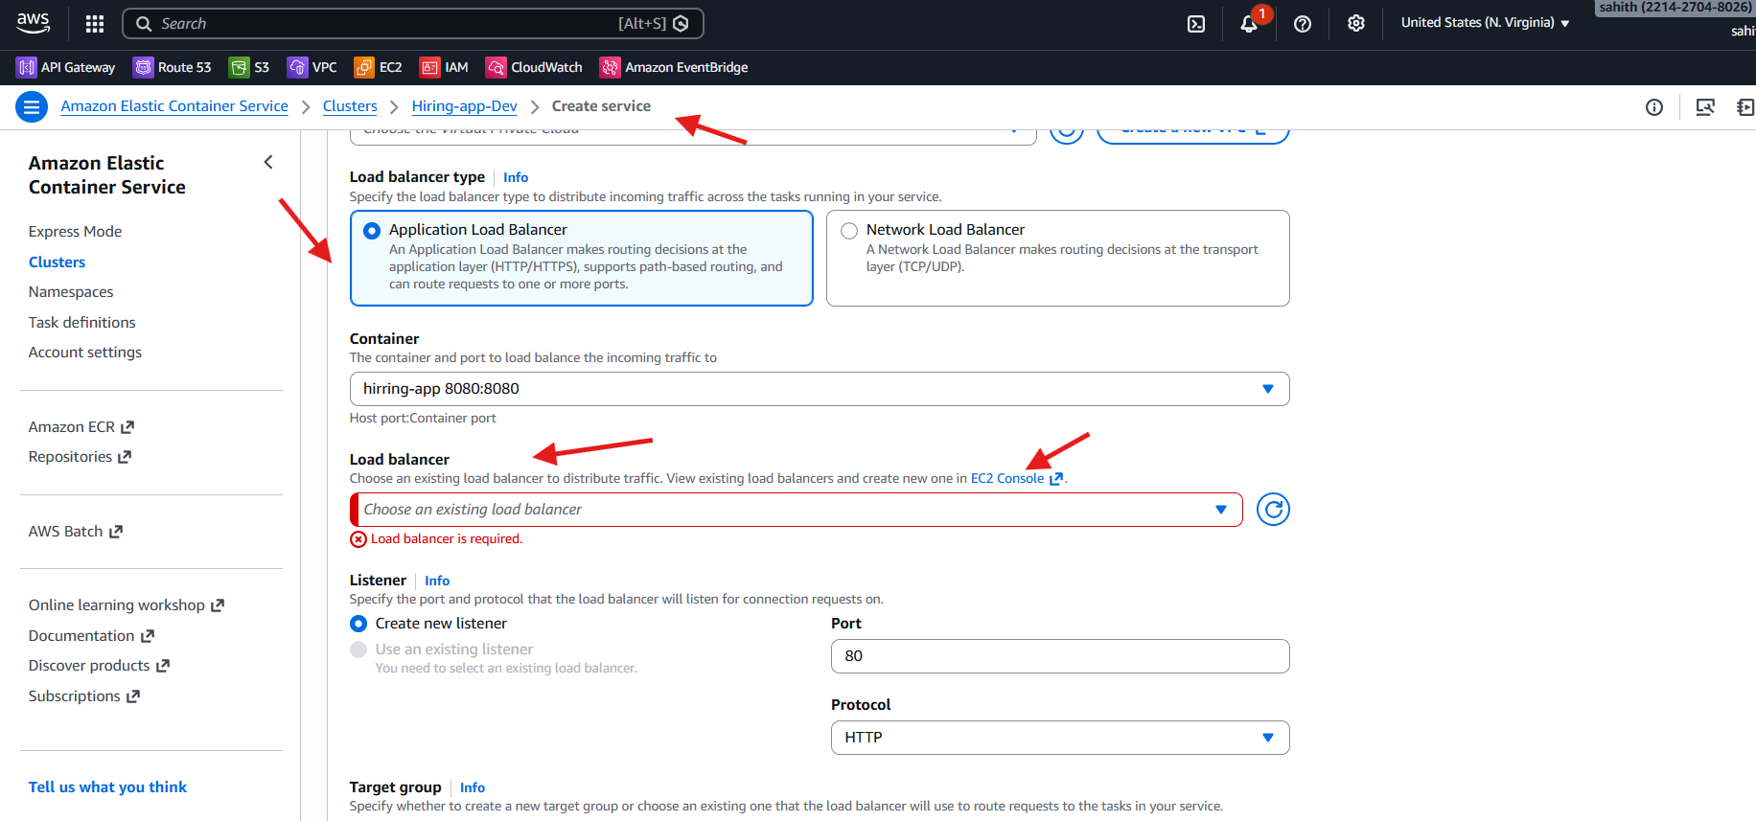
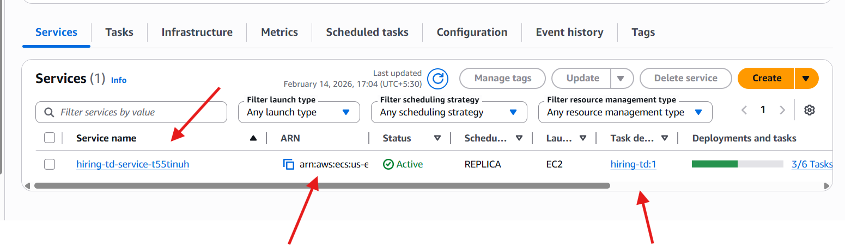
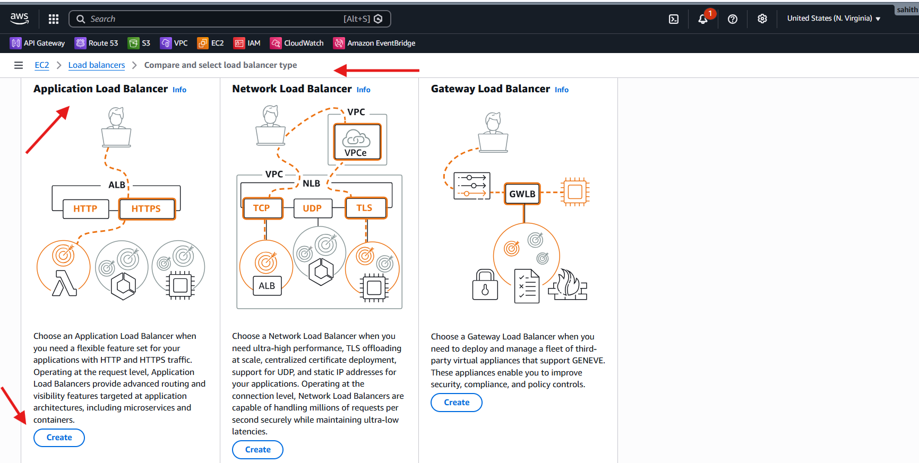
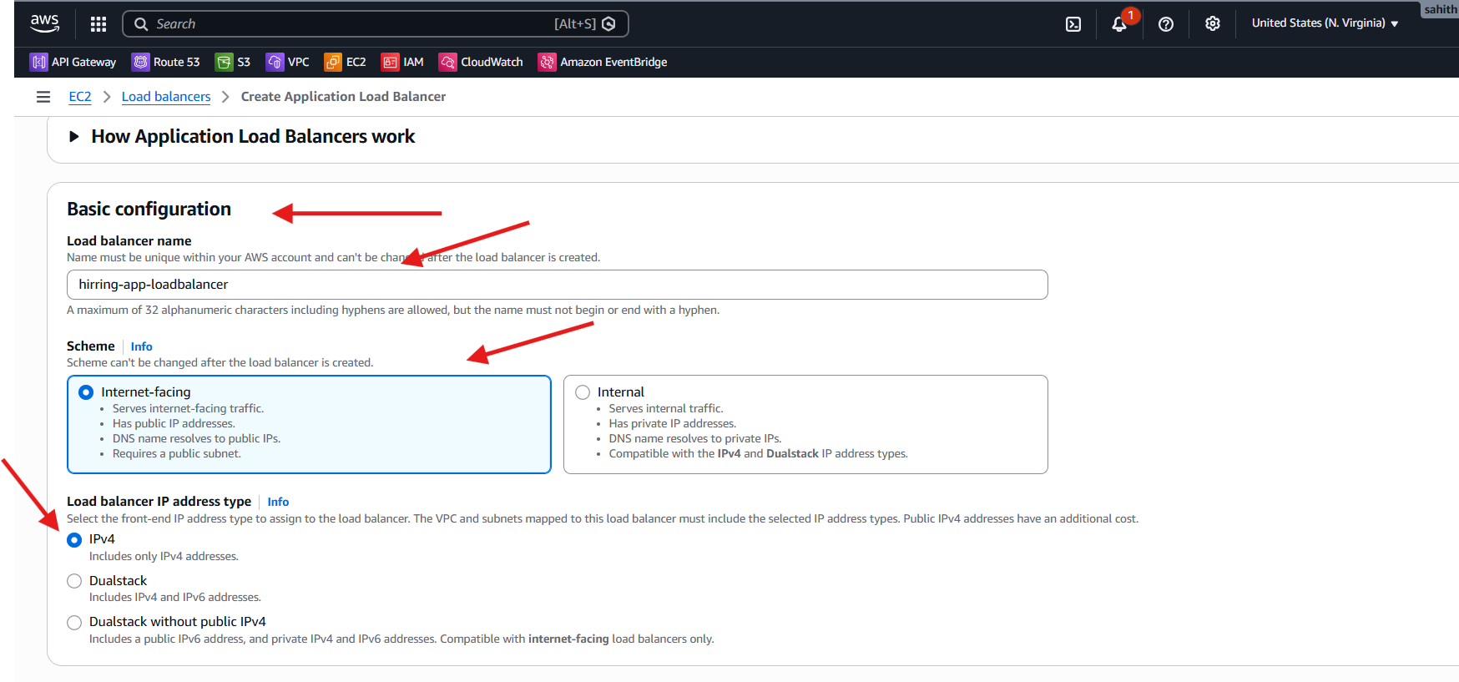
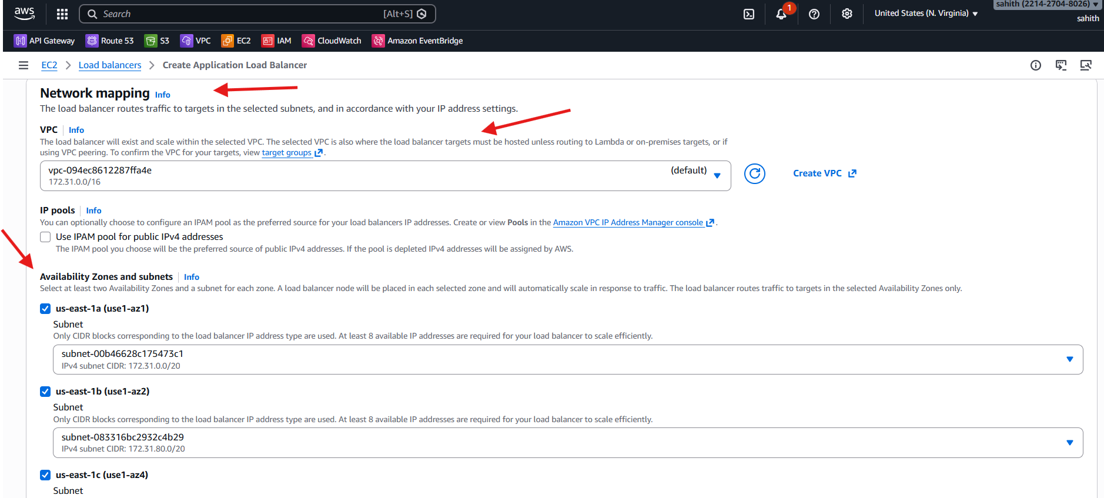
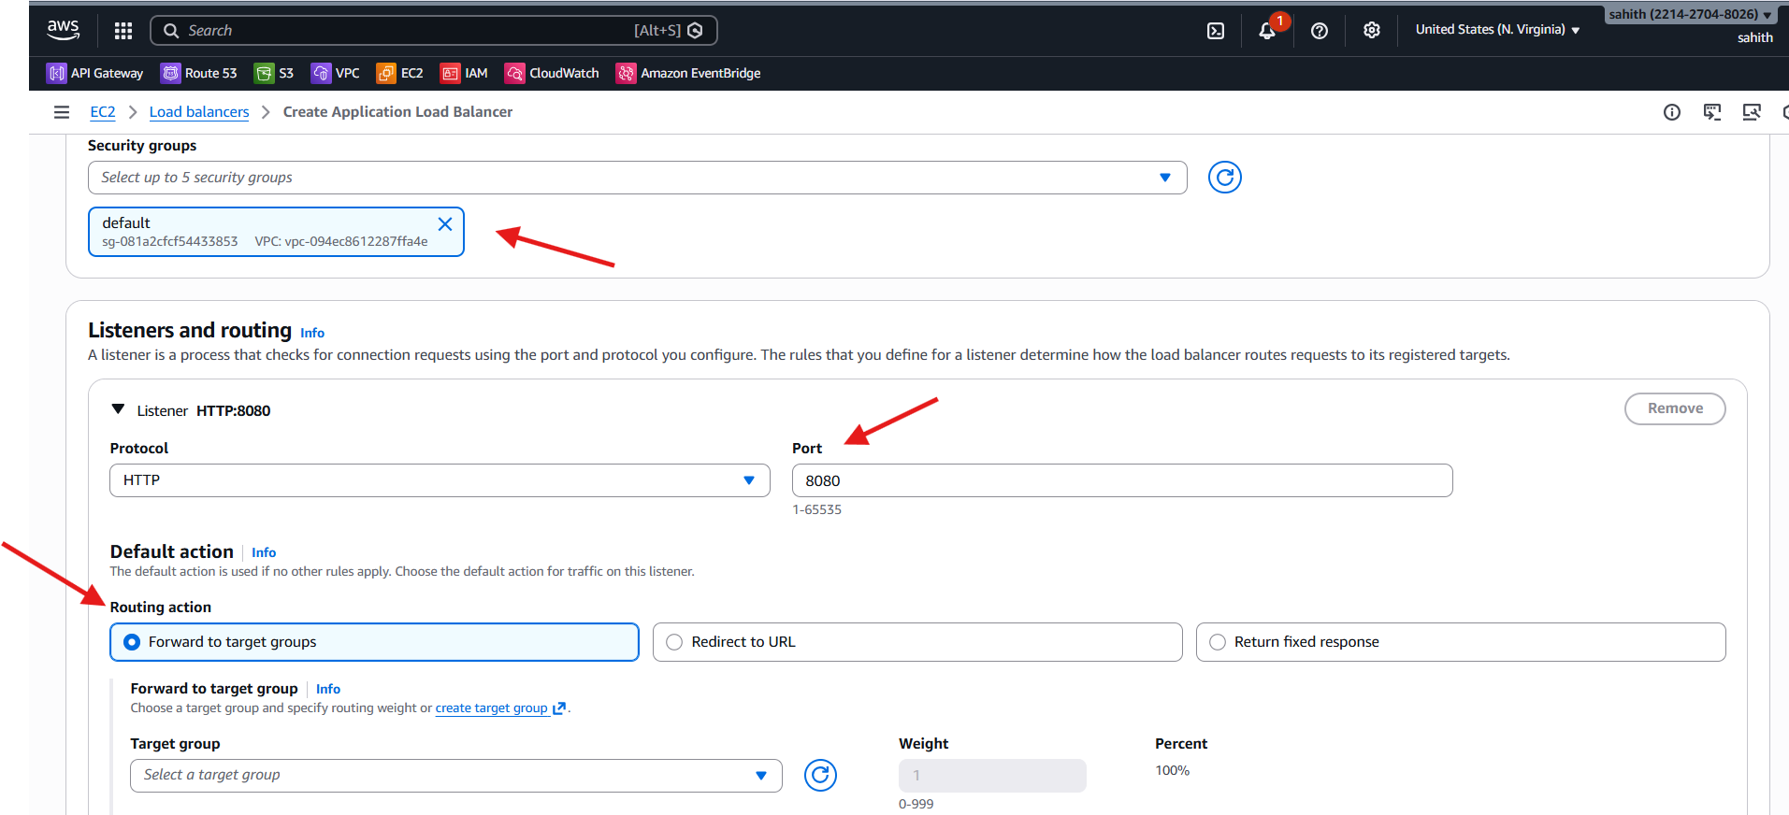
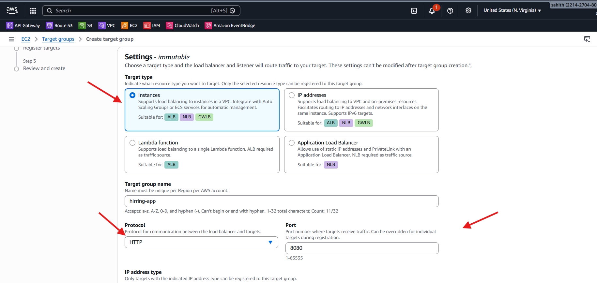
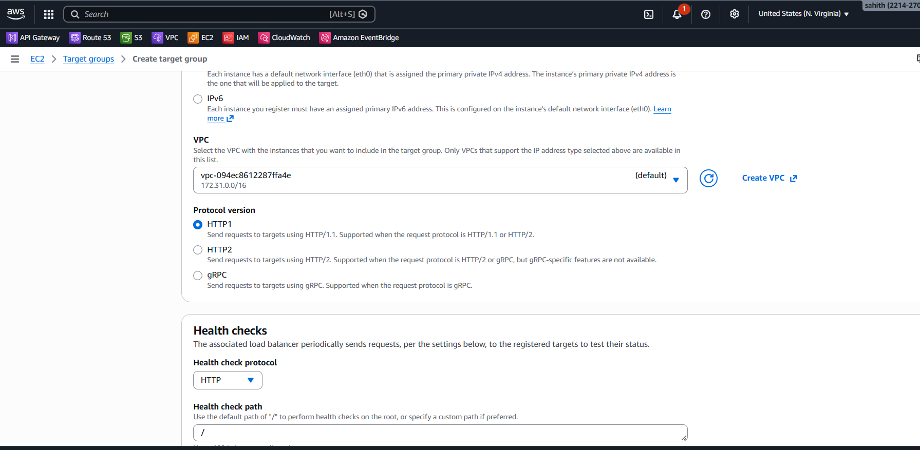
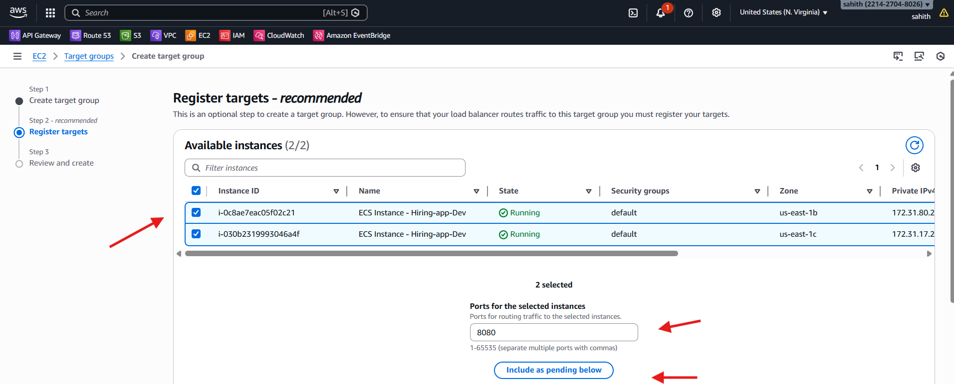
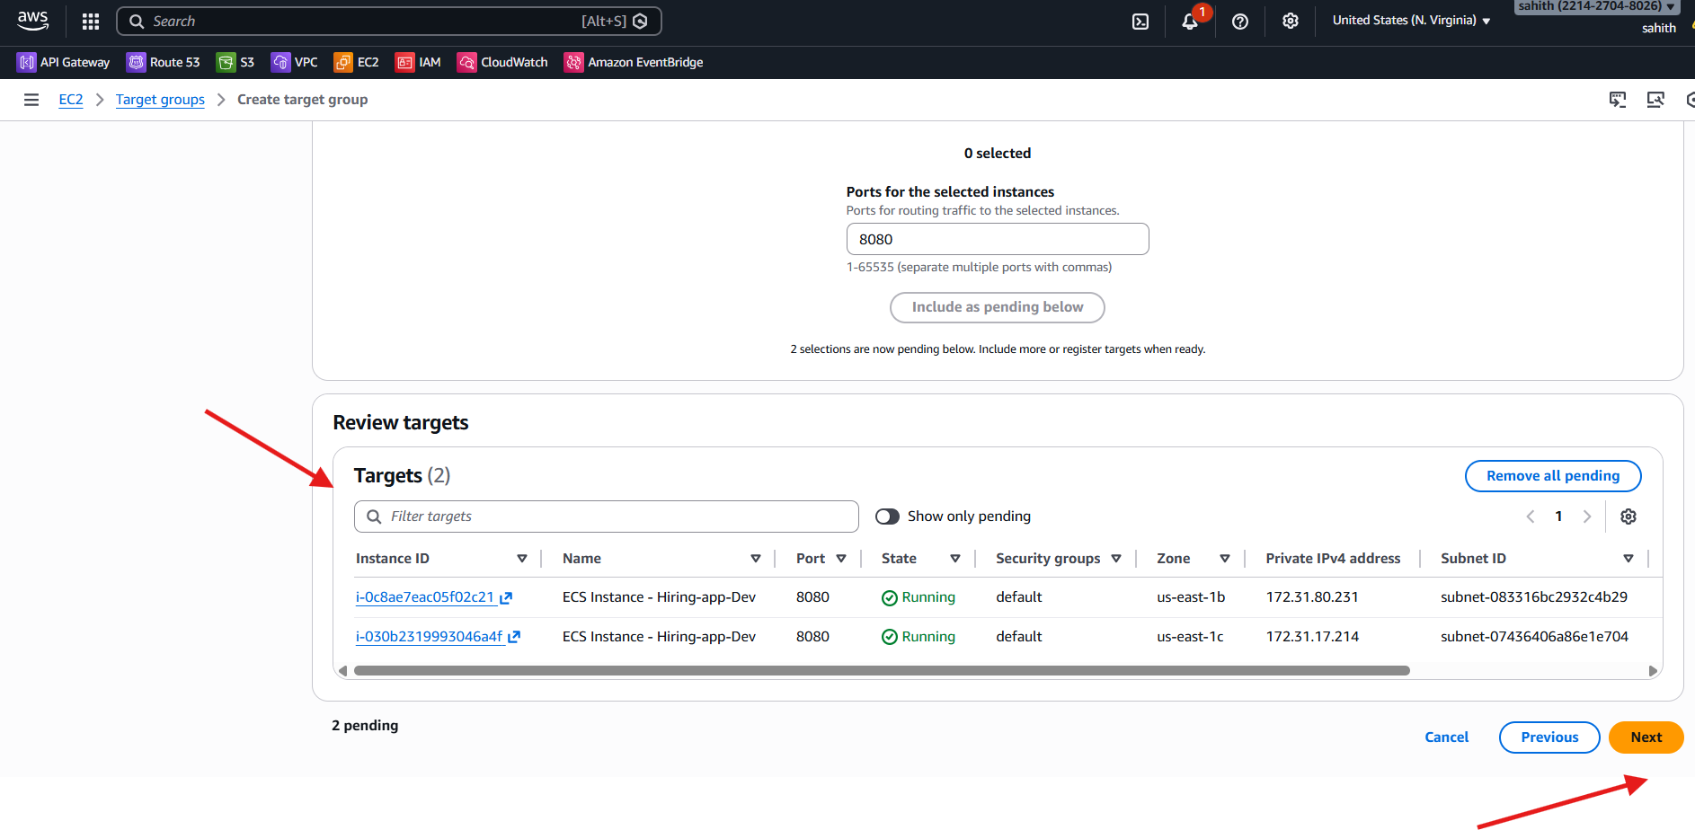
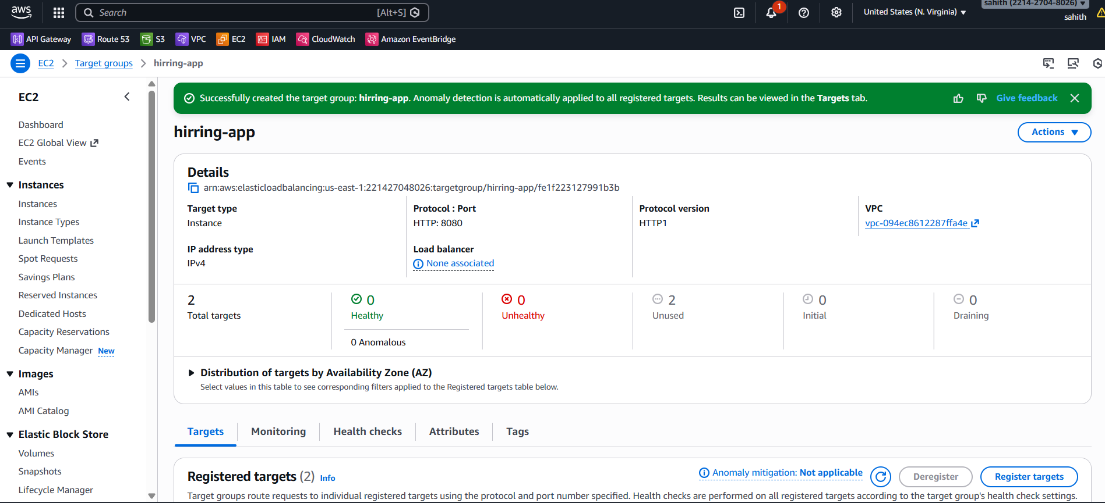
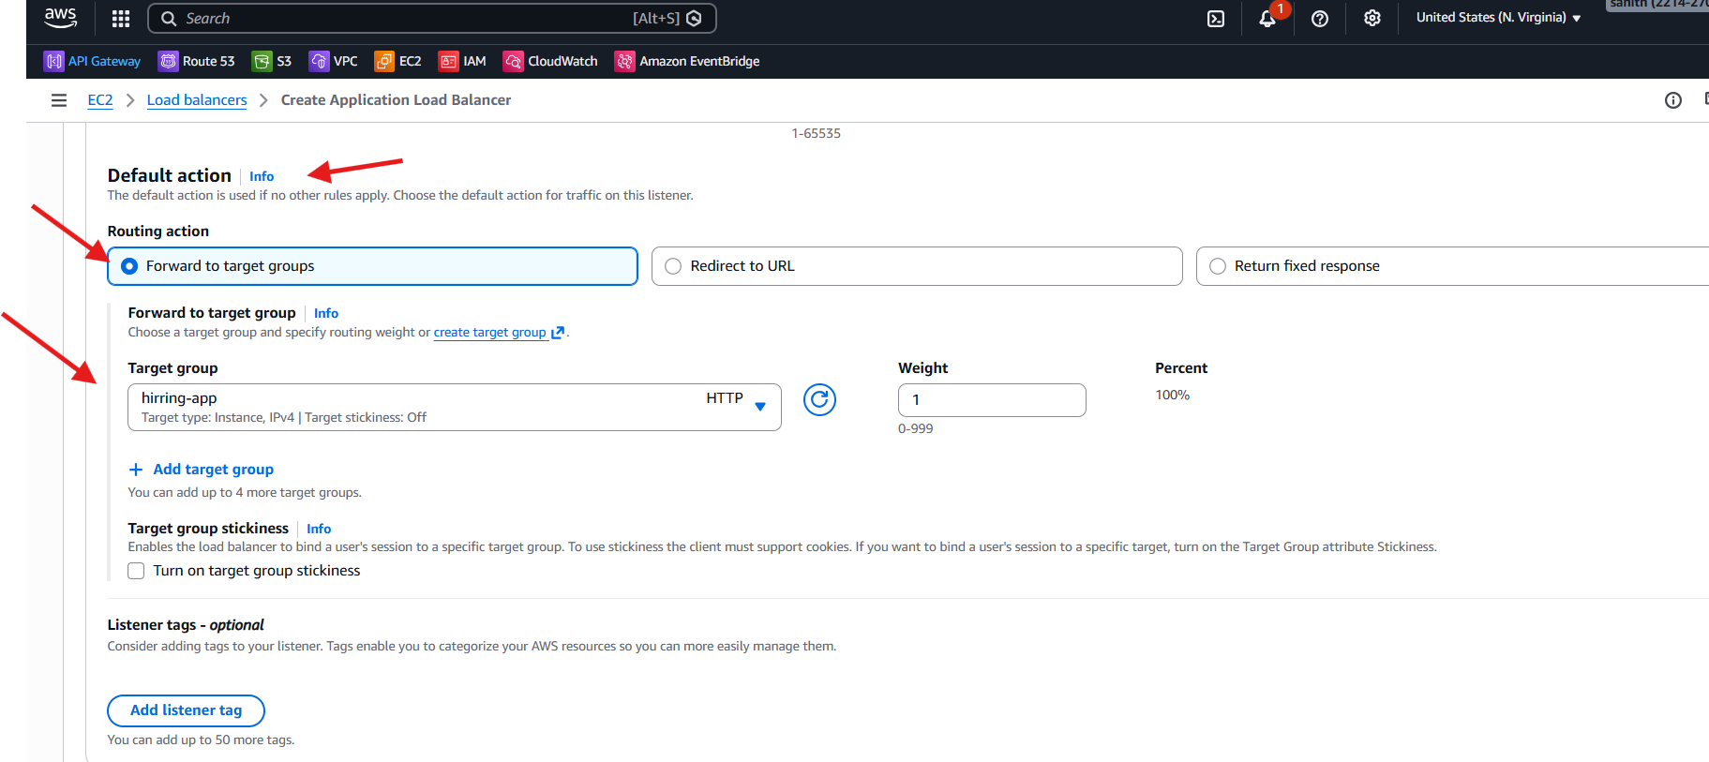
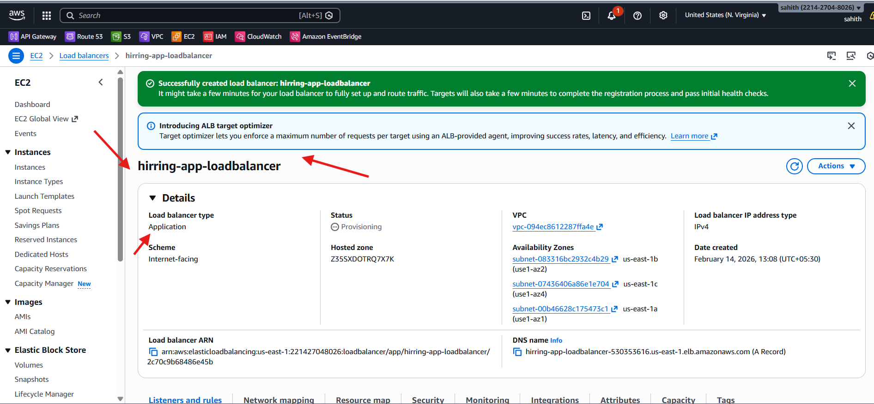

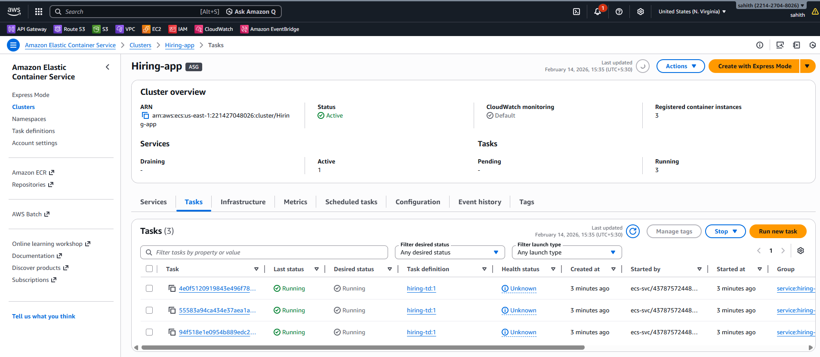
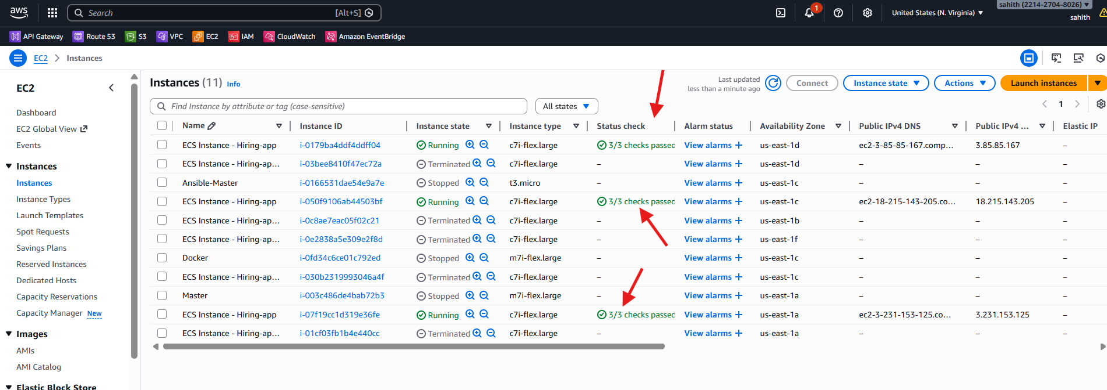
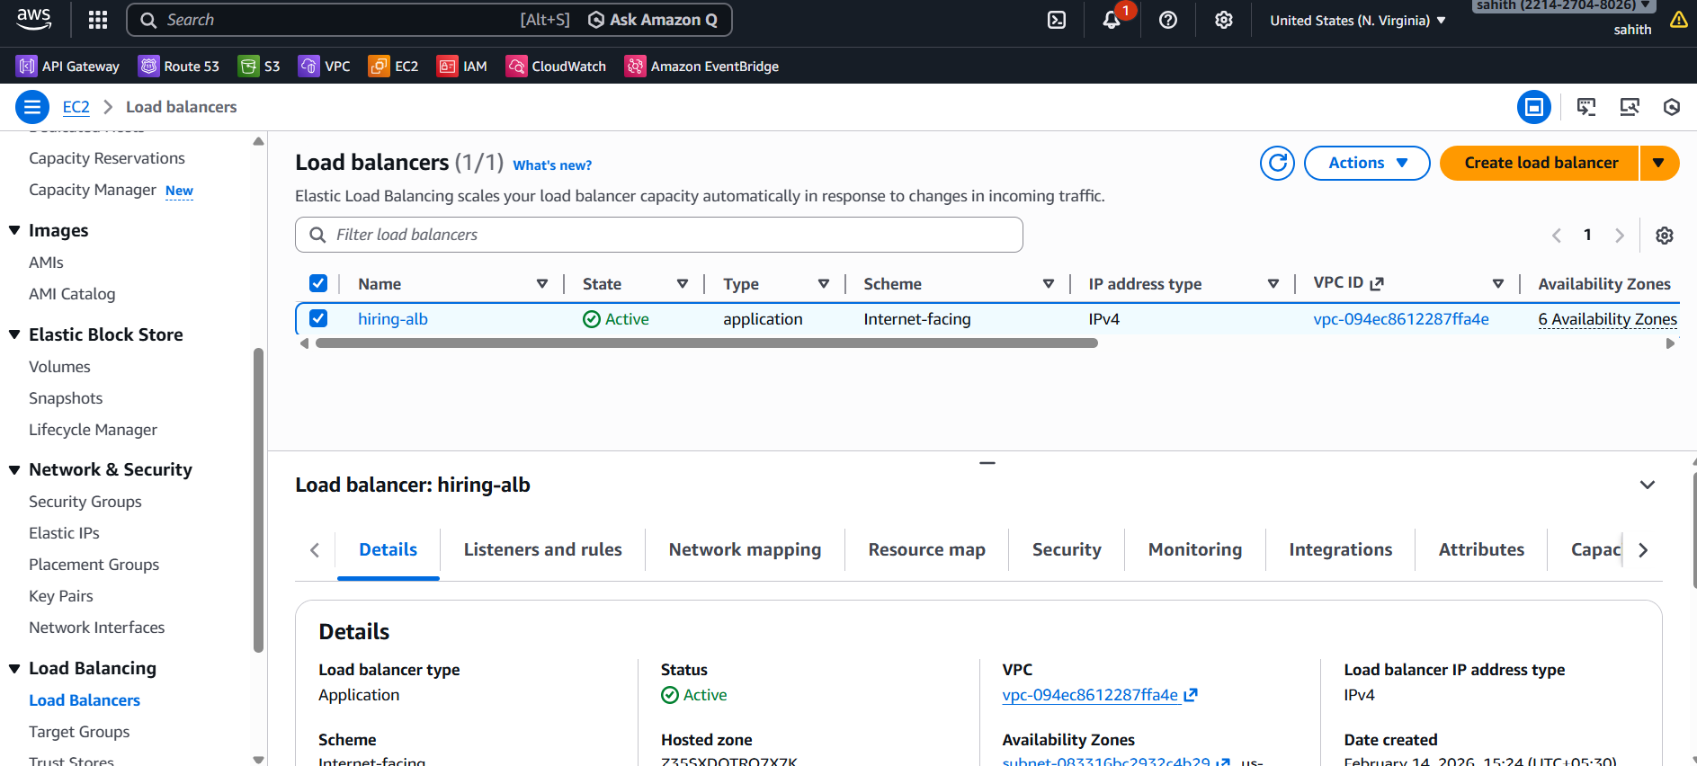
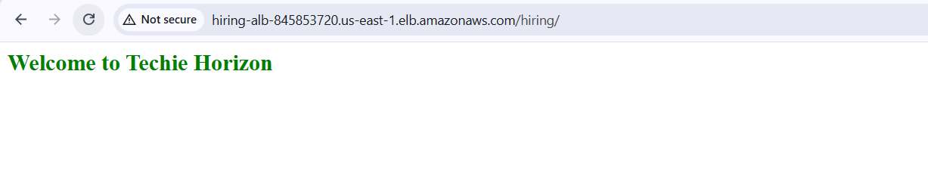
Issues Faced (Common Scenarios)
- Tasks stuck in Pending → Insufficient capacity
- Unhealthy targets → Incorrect container port
- No application response → Security Group rules missing
- Port conflicts → Host port not set to 0

Conclusion
Successfully implemented:
- Highly Available ECS Cluster
- Multi-AZ Deployment
- Application Load Balanced Service
- Dynamic Port Mapping Enabled
- Maintained Minimum 6 Running Tasks
- Application Successfully Accessible

